Title of the Paper
First Author Name¹, Second Author Name², Third Author Name³ (max 07 names can be cited)
¹ Author’s Affiliation, department, Name of the affiliated College or University/Industry, City, Country.
² Author’s Affiliation, department, Name of the affiliated College or University/Industry, City, Country.
³ Author’s Affiliation, department, Name of the affiliated College or University/Industry, City, Country.
Email: ¹First Author@gmail.com, ²Second Author@gmail.com, ³Third Author@gmail.com

Orchid Id number: ¹First Author id, ²Second Author id, ³Third Author id

Corresponding Author*: Author Name.

ABSTRACT:

The abstract should be in Times New Roman, Size 11, with single line spacing, and should not exceed 250-300 words. It serves as a non-technical summary of the main results and their implications. All symbols used in the abstract should be defined. Avoid citing references within the abstract.
KEYWORDS:
A manuscript should have a minimum of 5 keywords. Keywords should be in Times New Roman with Size 11, with single line spacing.
Specific requirements to start the body of the manuscript, should have:

- Introduction (research background)
- Methodology/ Literature Review/ Case Presentation
- Result
- Discussion [Optional]
- Conclusion
- Acknowledgment
- References
You may add more if required. {For Ex:} 1) Author contributions 2) Data availability statement 3) Conflict of interest 4) Funding Statement Etc.

- Introduction:
All headings and subheadings should be in Times New Roman, Bold, Size 12, with the first sentence starting from the introduction. The content in the body paragraphs should be in Times New Roman, Size 11, justified alignment, with 1.0 line spacing.
The first sentence of the research paper should start from the introduction [1]. Should have one spacing after section header. Content in body paragraph should be written with the Font style: Times new roman; Font size: 11; Paragraph: Justify; Line spacing: 1.0. (For example: The last few decades have witnessed vast research on new types of heat transfer fluids, namely nanofluids. Nanofluid is a fluid that contains nanometer-sized solid particles. The nanofluid was introduced by,[2] ..)
2) Methods and Methodology:
There are no word limits for the methods section, ensuring adequate experimental and characterization data for reproducibility. Figures should be of high resolution and clear, with captions and citations in Times New Roman, Size 11.
(a) Figure Style and Format
For manuscript publication, all provided figures must follow the high quality with high resolution figure. Content given inside the figure should be clear and readable as shown in the figure 1(a) and 1(b)
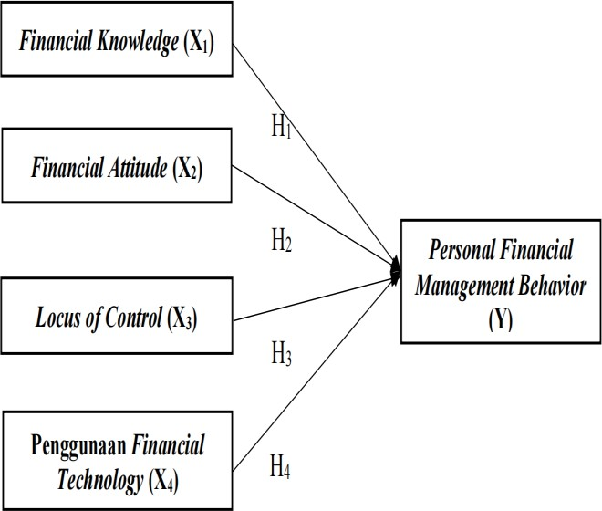

Figure 1(a) Research Framework

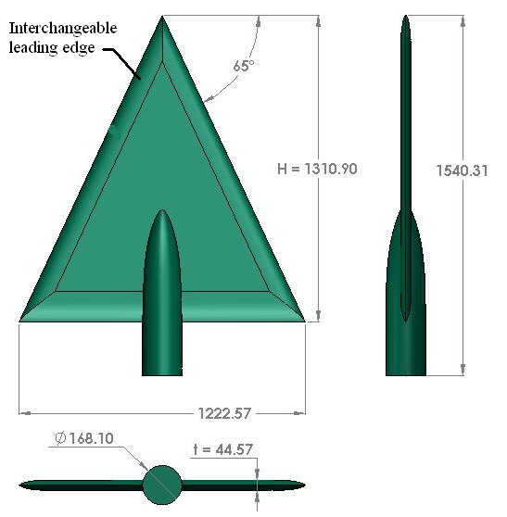

Figure 1(b) Main Model Outer Diagram
Each Figure must be discussed or mentioned in a body paragraph. The Figure must be placed under the paragraph that discussed about the Figure. Use the suitable size of Figure. Not too big. Every figure should closed with caption with citations as shown in figure 1(a) and 1(b).
(b) Table Style and Format

The table should be placed at the center. Each Table must be discussed or mentioned in a body paragraph. The Table must be placed under the paragraph that discussed about the Table. Font style and font size of content in the Table are times new roman and 10, respectively. The font size of Table caption is 11.
For example: Table 1: Table 1, the overall variables in this study have an AVE value of > 0.5.

Table 1. AVE Value

Variable | (AVE) | Description
Financial Attitude (FA) | 0.551 | Valid
Financial Knowledge (FK) | 0.505 | Valid
Locus of Control (LOC) | 0.556 | Valid
Penggunaan Financial Technology (PFT) | 0.534 | Valid
Personal Financial Management Behavior (PFMB) | 0.542 | Valid

Note: every table should have short description under the table and Closed borders.
For example:
The test configuration for this experiment is in Table 1. Nevertheless for the experiment at Reynolds number of 2×106, the angle of attack was limited to α = 23° only.

Table 1

The values of Reynolds number and velocity

Reynolds number, Re | Velocity, V
1×10⁶ | 18 m/s
2×10⁶ | 36 m/s
To differentiate the effects of Reynolds number, the experiments was also performed at two speeds of 18 m/s and 36 m/s that corresponding to 1×106 and 2×106 Reynolds number, calculated from Eq. (1) and summarize in Table 1.
(c) Equations:
Include any equations or mathematical expressions in the main body of the document. Identify equations referenced to in the text by supplementary numbers, such as (1), and refer to them in the manuscript as "equation (1)" and so on.
Note: please make sure that all equations are provided in an Text box, ( should be in text format not in picture format.

Correct Format: ,, , , ,

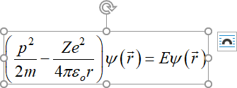
In-Correct Format:

3] Results: Present the findings of the research paper in this section.
4] Discussion - Provide detailed interpretations and implications of the results.
5] Conclusion – Summarize the main outcomes and their significance.
6] Acknowledgement: The author can acknowledge the key contributors, support staff, and funding agency in a brief manner.

Correct Format: We thank [Author 1], [Author 2], and [Author 3] for their contributions to this work. Special thanks to [Institution/Support Staff] for their assistance and [Funding Agency/Grant Number] for financial support.

Incorrect Format: Please refrain from acknowledging personal relationships, friends, family members, or making references to religious beliefs in this publication.

7] Funding Statement: State the source of financing

Correct Format: This research was supported by [Funding Agency/Organization Name] under Grant Number [Grant Number]. Additional support was provided by [Secondary Funding Source, if applicable]. We also acknowledge the funding from [any other relevant organizations or institutions]. The funders had no role in the design of the study, data collection and analysis, decision to publish, or preparation of the manuscript.
Otherwise state "No financing / There is no fund received for this article" or "The authors did not receive financing for the development of this research".

8] Data Availability:
Declare the availability of the data used in the manuscript

Correct Format: The data that support the findings of this study are available from [source, e.g., "the corresponding author," "the relevant public repository/ datasets link"].

Otherwise, please add the “No new data were created or analyzed in this study. Data sharing is not applicable to this article”.
9] Conflict of interest: Declare potential conflicts of interest; otherwise declare "None" or "The authors declare that there is no conflict of interest".
10] References:
The list of references should only include works that are cited in the text and that have been published or accepted for publication. Personal communications and unpublished works should only be mentioned in the text not in references.
How to Cite the Reference?

- In- Text Citation: You can cite the reference into the in-text in the numbering such as [1], [2]…..
For example:
Tracheostomy is a surgical procedure to establish direct communication between trachea and external environment by creating an opening into the anterior wall of trachea and introducing a cannula into it. Many ancient texts described tracheostomies performed in ancient Egypt. Tracheostomy is considered one of the oldest surgical procedure [1]. While performing pediatric tracheostomy, chances of complication are more especially in newborn and infants [2]. The indication of pediatric tracheostomy has changed over the years. In modern time, long term outcome of tracheostomy is considered satisfactory due to more specific indications [3]. The main objective of the present study was to analyze the complications of the pediatric tracheostomies in our institute and methods used to tackle the complications.
(b) Sample Reference [Only for reference Purpose]

Correct Format: [1] Author Name, Title of the article, Journal Name, Year, [volume, Pg no, DOI etc.]

[1]. Jiang WG, Sanders AJ, Katoh M, et al. Tissue invasion and metastasis: Molecular, biological and clinical perspectives. Seminars in Cancer Biology. 2015; 35: S244-S275.

11] Miscellaneous:
Any figures, tables, supplements, appendices, or annexes that are placed after the reference. Must include text citations for them in the body of the manuscript.

#### IMPORTANT NOTE: AUTHOR’S REFERENCE ###
Please note that the manuscript template provided is intended solely for initial submission and screening purposes.
Upon acceptance and journal confirmation of the manuscript, authors are required to ensure that the manuscript complies with the specific guidelines provided by the journal. This entails adhering to formatting requirements and revising the manuscript in accordance with journal policies.
We greatly appreciate your adherence to these guidelines, as it facilitates a seamless review and publication process.

